auto0Rocky Mountain Woodturners

*A chapter of the American Association of Woodturners*

*April 2009 Newsletter*

**Contents of Newsletter**

RMWT Meetings

Each month the Rocky Mountain Woodturners meet at Woodcraft of Loveland, located at 3718 Draft Horse Drive, Loveland, Colorado. We meet on the first Thursday after the first Tuesday of each month.

Meeting Format

6:00 – 6:30 – Setup and Social Time, come visit, share ideas and ask questions

6:30 – 7:00 – The general business meeting.

7:00 – 8:30 – Demonstrator time.

8:30 – 9:00 – Clean up and out by 9 pm sharp!

**Scheduled Meeting Demonstrators**

* April 9, Larry Fox, inlaying fine line turquoise
* May 7, David Nittman, airbrushing
* June 4, John Giem, How to make a Cryptex.

**2009 Officers, Directors and Committees**

President: Drew Nichols

970-566-4662

[dcnichols2004@msn.com](mailto:dcnichols2004@msn.com)

VP: Katherine Kowalski

[katherine@daystarhandworks.com](mailto:katherine@daystarhandworks.com)

Phone: 307-637-2874

Treasurer:

Secretary / Newsletter:

John Giem   
(970) 223-0844

<mailto:jgiem@comcast.net>

**Newsletter Team**

Editor: John Giem

970-223-0844

jgiem@comcast.net

Distribution:  
 Kevin Dunn

970-420-9691 Cell

dnnkk@msn.com  
Members:  
Randy Glecker  
Pete Herman

**RMWT Program Director:**Trent Bosch

970.568.3299

[[trentbosch@yahoo.com](mailto:trentbosch@yahoo.com)](mailto:trentbosch@yahoo.com)

**RMWT Librarian:**David Amos

970.834.1432

[dcjeamos@juno.com](mailto:dcjeamos@juno.com)

**Wood Bank Chairman:**

Kevin Dunn

**RMWT Symposium** Directors:  
Mike Davis -   
<mailto:mikeldavisllc@msn.com>  
Allen Jensen

970-663-1868

[Rajconst@aol.com](mailto:Rajconst@aol.com)  
Registration:  
John Giem  
970-223-0844  
<mailto:jgiem@comcast.net>

**RMWT Webmaster** Hoyle Curtis

<hoyle.curtis@gmail.com>

* Next RMWT Meeting, Demonstrator
* Treasurer Resignation

RMWT Activities

* Wood Bank
* Toy Drive
* Summer Youth Activities
* Empty Bowls update
* Officers Board Meeting
* March Demo, Turning Alabaster
* Charter Bus Information
* Letter from the AAW

**Next RMWT Meeting**

The next meeting of the RMWT will be on April 9, 2009. The demonstrator will be Larry Fox, Inlaying Fine-line Turquoise.

Note from Larry on his demo;

**Creating Inlays With Turquoise  
And Other Materials**

At one time or another, we have all filled natural cracks and checks with some sort of material because we had to. I will demonstrate how to fill man made tracks and troughs with turquoise and other materials because I want to.

The first part of the demo will be using tools you already have for cutting grooves on the top, side and bottom of turned pieces. I will then fill the troughs with turquoise using a process that will also apply to other substrates.

The second part of the demo will be using equipment I’ve fashioned from tools you may or may not have. In this section we will get creative with simple but elegant designs on the inside of bowls. I will then show you the secrets of filling these tracks with turquoise, or other materials so that they appear to be part of the wood.

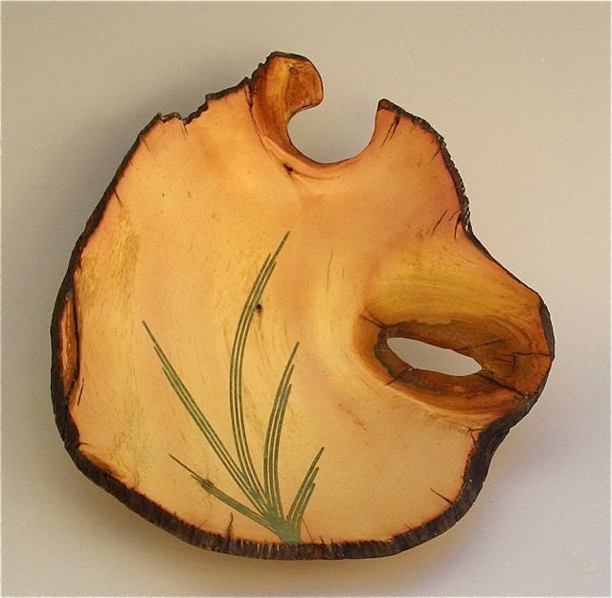

**RMWT Treasurer Resigns**Richard Bailey has resigned as Treasurer due to health reasons. The RMWT Board expresses great thanks to Richard for his past support and services to the RMWT. We encourage all members to keep Richard in their thoughts in the coming months. Please let Richard know your best wishes for him.

**Special Election for Treasurer**Drew Nichols, President, has all of the Treasurer’s records and is the acting Treasurer, per the By-Laws, until a replacement can be elected. The Board has contacted Pete Herman and asked him if he would accept a nomination to be Treasurer. He agreed to accept. At the next RMWT meeting, Pete Herman will be presented as nominee to the position of Treasurer, additional nominations will be accepted from the floor and then a special election will be held.

**RMWT Activities**

***Wood Bank:***

The Giem Branch of the Wood Bank has been quite active since the last RMWT meeting. There have been at least five pickup or trailer loads of wood deposited. We now have available a wide variety of wood including; maple, elm, walnut, olive, aspen, locust, and some mystery woods. Some of the wood is somewhat seasoned yet other pieces are freshly cut. There are blanks that are ready to mount on your lathe and others that need to be treated to a session with a chainsaw. John Giem, 223-0844, is willing to help you find just the wood you need and yes, he has a chainsaw and can use it.

The objective of the Wood Bank is to make turning wood available to RMWT members at no or little cost. If any member needs wood for their wood turning activities, contact any Club Officer or a Wood Bank member (see Kevin Dunn or John Giem).

***Toy Drive:*** It has come to our attention that several Civic Organizations provide toys to our community children at Christmas time. We need a Committee Chairman to organize the making of toys, with or without using a lathe, to donate to this cause. Most organizations collect toys during November for distribution during December.

**Challenge:** Use your ingenuity to make one or more toys, any age group, and bring them to the November 5 meeting.

***Empty Bowl Silent Art Auction***: Many of you donated items to the Empty Bowl fund raiser for the benefit of the Food Bank for Larimer County. Each of you should have received a Thank You letter with some details of the Auction. Here is some additional information to help all of us understand the Auction and its operation.

This year the event received 108 items for the auction and raised over $57,000. There were 580 people attending. All of our woodturnings were sold. The bidding on each item started at 50% of the Artists declared value with each piece having minimum required bid increments. For example: a piece valued at $40.00 would require a starting bid of $20.00 and subsequent bids would have to be in $5.00 increments.

**RMWT Board Meeting**

On March 25, the RMWT Board met. In attendance were Drew Nichols, president; Katherine Kowalski, VP; and John Giem, Secretary. Also present were Dave Amos, Librarian and Pete Herman, nominee for Treasurer.

***Library*** *-* Dave Amos reported on the status and plans for the Library in light of the non-approval of the request for a grant from the AAW. Decisions made:

* Proceeds from the monthly raffle or auction will be designated to support the Library.
* The assets of the Library are important and should be treated with respect and we should use diligence to preserve them.
* The Librarian will make additions to the Library at the targeted rate of $100 per month.
* Donations to the Library qualify for tax deductions, any donation exceeding $25.00 will receive a receipt.
* Members will check out and in items from the Library (records will be kept).
* Dave needs a volunteer to assist in checking items in and out of the Library.
* A Labeler will be obtained to label all Library assets.
* The Library assets will be computerized and organized, we will attempt to implement an email reminder to return over due items.
* Will investigate improvements in storage of Library assets.

***Storage of Important Documents and Records*** - This has been an ongoing issue with many of our documents and records scattered among our members.

Action:

* Start collecting and consolidating all of the important and historical documents of the RMWT.
* In the proposed new Library cabinet, place a small filing cabinet and a small safe to store the documents.
* Develop a records retention policy for the RMWT.

**Richard Bailey -**

* Katherine will have a card at the next RMWT meeting for all members to sign and send messages to Richard.
* In honor of Richard’s interest in turning chess pieces, a Challenge will be organized to encourage each member to turn a chess piece for Richard. (This will result in a really unique chess set.)

**RMWT Trailer**

* The trailer is now in our possession. It is being stored at John Giem’s along side of the Wood Bank.
* Drew and Martha Nichols are developing a possible sign to put on the side of the trailer, “Ask me about woodturning” along with contact information.

**Wood Bank**

* Authorized to purchase wood sealer for usage on ‘processed’ wood
* Authorized the reimbursement for gas and oil for chainsaws used in supporting the Wood Bank.
* When possible, each Student attending a RMWT meeting is to receive one piece of turning wood per meeting. They are encouraged to bring resulting turned piece back to be displayed in the Instant Gallery.

**Newsletter**

* All members, in particular our Professionals, are invited to submit a short paragraph to inform the rest of the Club about what is happening in their world of woodturning.
* Randy Gleckler has resigned from the Newsletter Team due to his relocation related to his Wife’s employment. Thank you Randy for your support of the Newsletter.
* The Newsletter Team would like to have one or more volunteers to assist in gathering information and publishing the Newsletter. If interested, contact John Giem.

**Summer Picnic**

* There will be a Summer picnic in place of the Holiday Season party. (The weather should be better.)
* A Chairperson is needed to organize the picnic and activities. Contact Drew Nichols.

**RMWT By-Laws**

* A committee has been formed to review the RMWT By-Laws and to recommend any revisions that may be needed.
* Chairman - John Giem  
  Members - Hoyle Curtis  
   - Pete Herman

**A Letter from your Librarian**

One of the significant benefits of the Rocky Mountain Woodturners Club membership is our Club Library of books and videotapes related to Woodturning. You will be able to find books, videos and magazines relevant to all stages of interest, for beginners, intermediate, and experienced turners, by noted artists and practitioners. In addition, there will be numerous video tapes taken at the American Association of Woodturners annual conventions, featuring demonstrations of special techniques and the critiques of turnings displayed.

All library items are available for borrowing by Rocky Mountain Woodturners members ONLY. The standard policy allows three items per month per member, and operates on the Honor System. That means that you will be checking-out (signing the checkout form) the library item and then be responsible for returning that item on or before the next monthly meeting.

There will be new additions monthly to the library. Please, if there are videos, books other material that you would like to see in the library please let me know. Also dig through your old videos, books, magazines or anything else you might have laying around your shop that's woodturning related and donate them to the library. Just drop it off with any club officer or myself and I'll add it to the collection.

There are several items that went missing from the library. If you have seen them please bring them home so we can update our records.

The plan is to have a complete list available for viewing on the web site.

Editor’s Note: Dave has been video taping each meeting’s demonstrations and downloading them to DVDs. These DVDs may be available in the future for your review.

Making things Round

Dave the Librarian

**Turning Alabaster**

Demonstrated by: Max Krimmel  
Reported by: John Giem

The demonstration at the March 5, 2009, Rocky Mountain Woodturners was given by Max Krimmel on how to turn Alabaster on the lathe.

Before his demonstration, Max reviewed the Instant Gallery and made several interesting comments:

* People often quit too soon in finishing their projects. He doesn’t like to see any scratches.
* To finish his turned wooden items, he likes to use 2 or 3 coats of brush-on poly letting it cure for several days, then sands it lightly followed by a couple of coats of wipe-on poly. After curing, he polishes and waxes it.
* He has observed that aniline dyes change color over time when exposed to sunlight.

*The Demonstration*

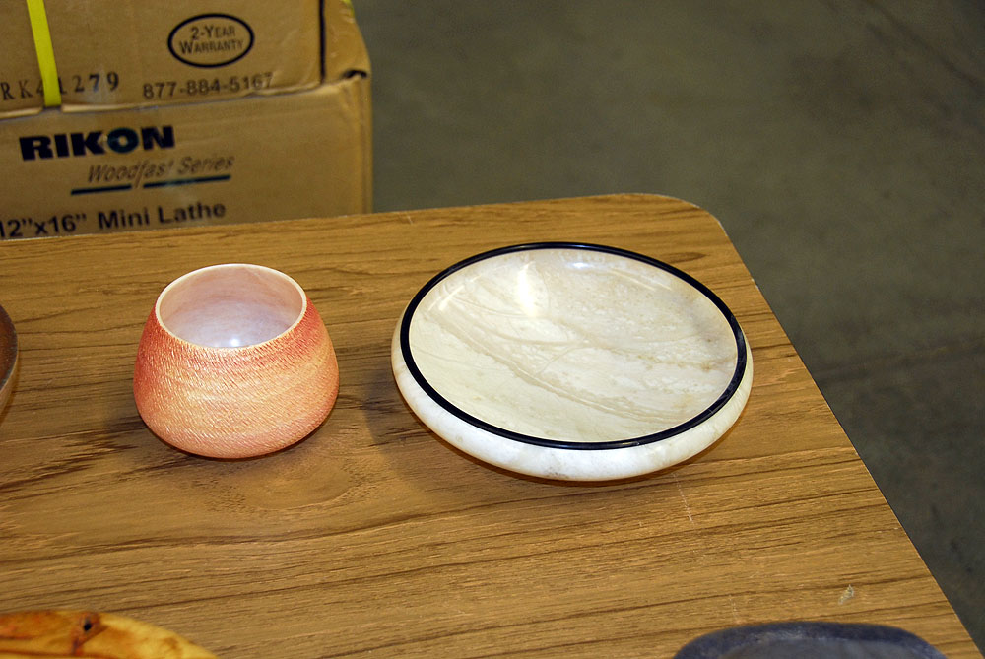

Figure , Examples of Max's work

Editor’s note: Many of the observations and guidelines expressed by Max below can be equally applied to woodturning.

Many times during the demonstration, Max referred to his web site, www.maxkrimmel.com, where extensive information can be found concerning his methods for turning alabaster. Sources are given for many of the materials and tools. It is interesting and well worth reading.

* Max became interested in turning Alabaster after watching a short demonstration by Lee Carter. (Lee is a member of RMWT.) His first attempt at turning alabaster was a success followed by many failures. Perseverance paid off in success.
* “The best way to turn alabaster is on someone else’s lathe in somebody else’s shop.” This is referring to the fact that it is a very dusty, messy process.
* One must protect their skin while turning alabaster since it is hydroscopic and will cause drying and cracking. Max wears protective gloves.
* Turning alabaster is a scraping process, not cutting.
* He makes his own roughing tools by brazing carbide onto steel bars.
* The holder for the roughing tools has an arm brace similar to that found on some hollowing tools. This is to help control the relatively high tool forces encountered.
* For finishing work, he uses high speed steel ( HSS ) scrapers.
* His best source of alabaster for turning is Colorado Alabaster located on North College in Fort Collins, CO.
* Alabaster is sold by the pound and weighs 155 pounds per cubic foot.
* Alabaster can be cut with a coarse tooth handsaw or on a slow running bandsaw, be sure not to use your best saw or saw blades.
* The first step in mounting a piece of alabaster onto the lathe is to drill a one inch hole into what will be the top of the finished item. This is then mounted onto a one inch pin chuck which is then mounted onto the lathe spindle.
* One inch masonry drill bits are oversized and must be ground down so that the resulting hole will fit the one inch pin chuck.

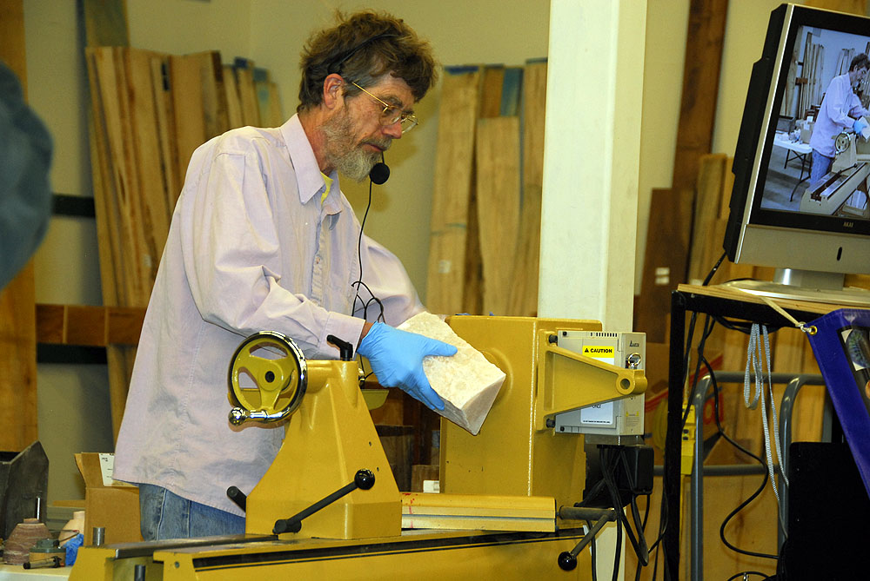

Figure , Mounting the alabaster on the lathe.

* He started the roughing process with the lathe running at 205 rpm. Turning alabaster is performed at relatively slow speeds compared to woodturning. Later when finishing, the lathe is run at higher speeds.
* He watches the size of the chips coming off to help gauge his cutting rates.
* The cutting (scraping) process is not like that used in woodturning, in that he is cutting grooves into the stone to separate the waste from the final item. Before

the grooves cut through, Max stops the lathe and uses a convenient hammer to tap the waste, breaking it off.

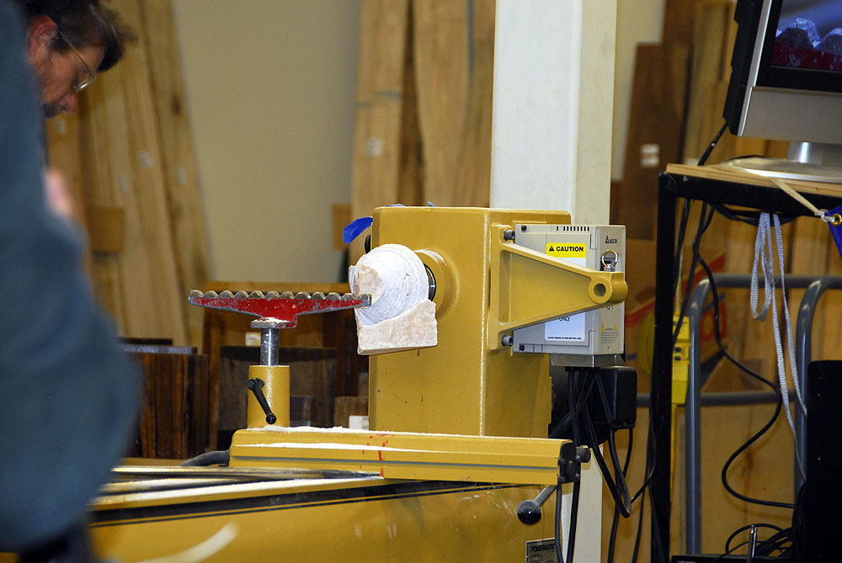

Figure , The waste is removed from the top, the bottom waste is next.

* After removing the perimeter waste, Max turns a spigot on the bottom of the vessel so that it can be mounted in a collet chuck.
* A small dimple is made in the center of the bottom of the spigot for later usage.
* The collet chuck must have smooth jaws to prevent damaging the alabaster spigot.
* The vessel is reversed and mounted using a collet chuck.
* The finish shaping is done with HSS scrapers. They provide a smoother surface finish than can be obtained with carbide tools. Yes, the scrapers still need sharpening but the bevel angle is not critical.
* For larger blanks, he will glue a wooden block onto the alabaster and then mount it to a faceplate. In some cases, the blank can be mounted to the faceplate using double sided tape. Be careful, the alabaster is heavy and the tape can creep. When the lathe is stopped, be sure the support the blank with the tailstock to prevent it from falling off. Alternatively, take it off of the lathe. If you don’t take this precaution, interruptions such as a phone call or restroom break, can place your alabaster on the floor separated into many pieces for you.
* Alabaster is a consistent material when compared to wood although it does have hard and soft spots due to inclusions of other minerals.
* On Max’s web site, he indicates that he vacuum impregnates the rough turned alabaster with a water-glue solution to strengthen it.
* He has quit using CA glue in that he has found it to be too brittle.
* Thin walls can make people (customers) afraid to pick them up and handle them for fear of breakage.
* Alabaster is water soluble, hence you should not put these items in the dishwasher nor use them to hold water.
* If the inside of the vessel can be seen, then the shape of the inside is as important as the shape of the outside.
* Alabaster sands easer than wood and does not clog up the sandpaper.
* He does not power sand alabaster, the resulting dust likes to eat up drills.
* When sanding Alabaster; keep it on the lathe, don’t turn too fast and don’t use too much tool pressure.
* He sands by hand starting with 80 grit paper and works his way down to 400 grit.

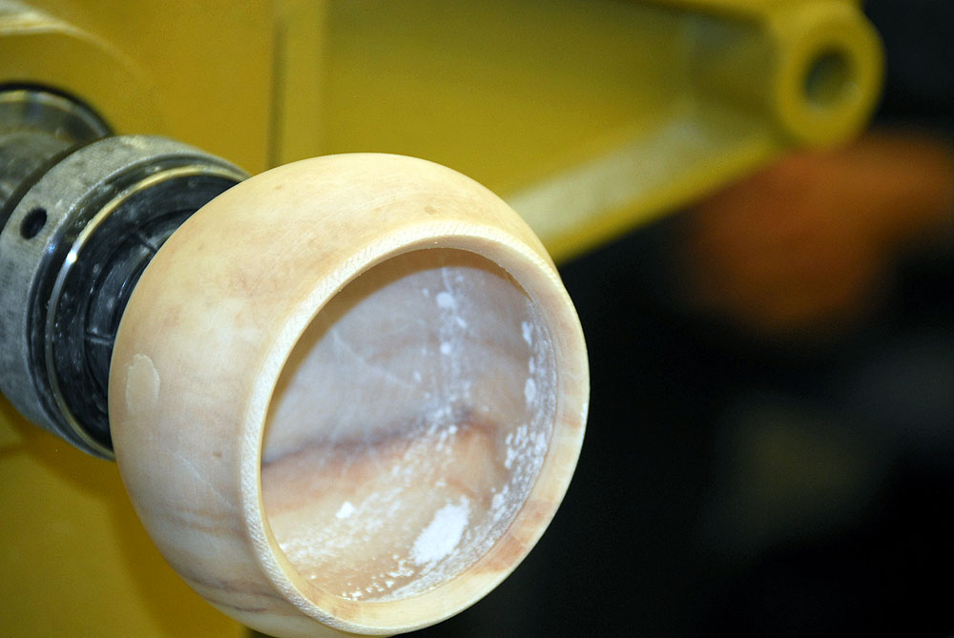

Figure , The sanding is completed.

* When the sanding was finished, he textured the rim of the vessel using a Dremel rotary tool equipped with a carbide burr. While the lathe was running, the rotating carbide burr was held at an angle to the axis of rotation and lightly applied to the rim of the vessel. The angling of the burr has been found to give the most pleasing textures.

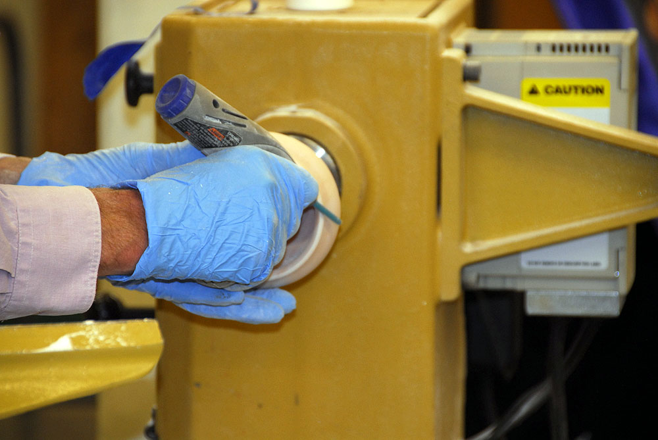

Figure , Texturing the rim

* After texturing, acrylic paint was applied to the textured area while the lathe was running at a slow speed. By keeping the lathe rotating, the risk of paint runs is minimized.

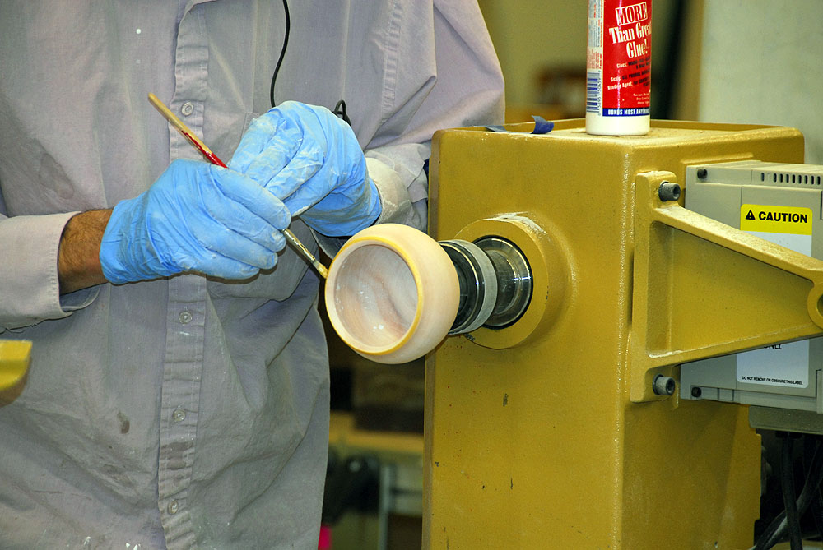

Figure , Applying paint to the textured rim.

* After the paint has dried and the lathe is running, the textured area is sanded lightly with 400 grit sandpaper. This highlights the texturing.
* The vessel is finished with wax and then polished.
* The next steps are to reverse the vessel and to mount it so that the bottom can be finished.
* In his own shop, Max would remount the vessel using a vacuum chuck. Here he needs to improvise.
* He uses a faceplate with the surface covered (padded) with closed cell foam.
* Remember that dimple he made in the end of the spigot? The top of the vessel is placed against the padded faceplate and centered. The tail stock is brought up to the bottom of the vessel and the live center is placed into the dimple on the spigot thus centering the vessel on the faceplate.
* The vessel was then secured to the faceplate using packing plastic wrap.
* After securing, the tailstock is moved away and the spigot is turned off of the bottom of the vessel. It was then sanded and finished.

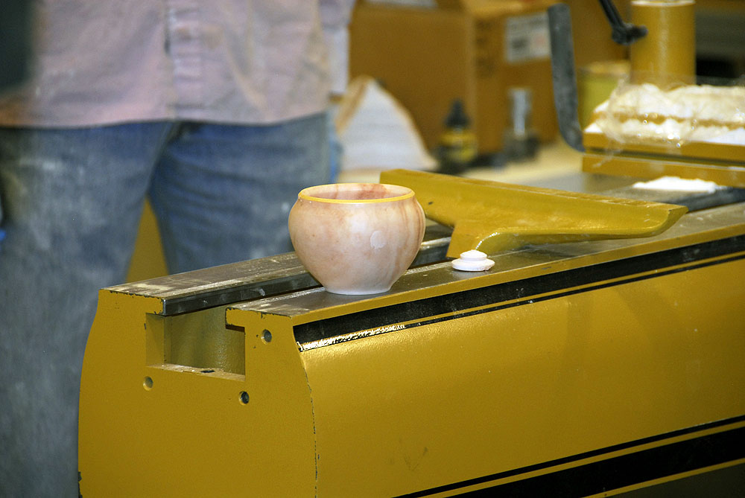

Figure , The finished vessel.

**Chartered Bus to AAW Symposium**

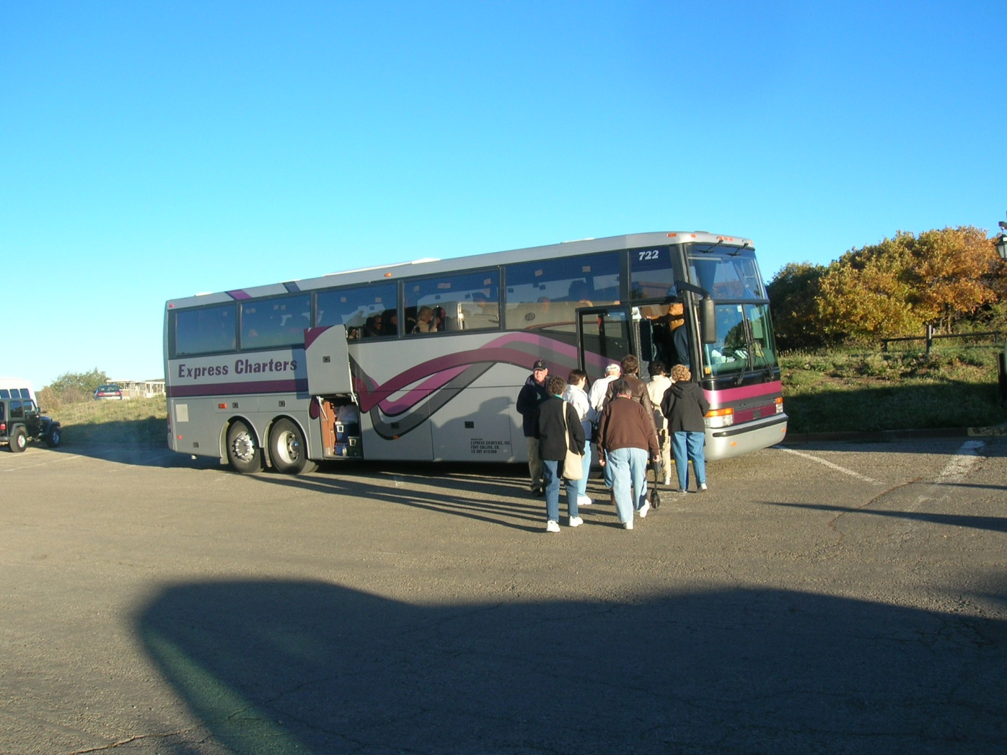

It has been proposed that those members who plan on going to the AAW Symposium, charter a bus for transportation to and from Albuquerque. The following is some information provided to us as a solution to this proposal. If you are interested in utilizing this resource, contact Drew Nichols and give him your information.

The bus is a 56 passenger bus with a bathroom. It will leave for Albuquerque, New Mexico, Thursday morning, June 25th and be there in time for the early check in Thursday evening (start time from Ft. Collins yet to be determined). It takes about 8 hours driving time plus one stop for lunch at a eating place decided by all passengers as long as the bus has a place to park. The cost is estimated to be $100 per person if the bus is full; it could be as high as $120 if short by 10 people.

The bus will pick up people in the Ft Collins/Loveland area, then one stop near I-25 in Denver and one stop in Colorado Springs near I-25. The driver says the bus has enough storage that if people buy something there, it will fit in the storage area and he will haul it back for us (small tools/wood). Since we are all responsible adults, he will permit liquid refreshments on the bus as long as we are responsible.

The bus driver will take people back and forth morning and night if we can all be in at least 2-3 motels in the same area. Plus maybe to dinner if people can choose the same place to eat and not have to take people to too many places all over town (this yet to be determined).

Sunday, the bus will leave for Colorado after Symposium is over (bus will leave about 4:30 pm). Again, it will stop for dinner somewhere along the way home.

We are needing people to confirm that they are using the bus service so we know how many people will be riding and that they will need to pay in advance of the trip so we have the money up front to pay for the bus. First come, first served, till we have the bus full.

**AAW Update Information on the 2009 Symposium**

The following updated information was sent to us concerning the 2009 Symposium being held Albuquerque.

Date: Fri, 20 Mar 2009 14:25:36 -0500

American Association of Woodturners

www.woodturner.org

**The 2009 Major Demonstrators:**

Nick Cook from Marietta, Georgia: Dynamic Plates and Platters

J. Paul Fennell from Scottsdale, Arizona: Seeing Your Way to Signature Work

Emmet Kane from Castledermot, Ireland: Texturing Experimenting with Woodturning Ebonizing and Gilding

Virginia Dotson from Show Low, Arizona: Secrets of Laminated Woodturning, Natural Perspectives, Weather Reports

Peter Hromek from Sinntal, Germany: Spindle: An End-Grain Hollow, Flower: A Multiaxis Form, Capsula: Multiaxis Form

Mike Mahoney from Orem, Utah: Turning Family Heirlooms, Coring Using the McNaughton Center Saver, Burial Urns with Threaded Lids

Rolly Munro from Manakau, New Zealand: Very Thin Deep Vase Form, Carved Hollow- form Surfaces

David Nittmann from Boulder, Colorado: Basket Illusion, The Cutting Technique, The Process and Inspiration

David Springett from Warwichshire, United Kingdom: Streptohedrons: Plain turning With a Twist

John Wessels from Bisbee, South Africa: Sheet Pewter as Surface Cast and Turning Pewter

**Featured Demonstrators and/or Panelists:**

Garry Knox Bennett, Trent Bosch, Marilyn Campbell, Andrew Chen, David Ellsworth, Peter Exton, Charles Faucher, Barry Gross, Allen Hockenbery, Sherry Hockenbery, Michael Hosaluk, William Ray Hughes, Douglas Jones, Deborah Kermode, Jerry Kermode, Bonnie Klein, Pat Kramer, Bill Luce, Alain Mailland, Andre Martel, Terry Martin, Larry Miller, Michael Mocho, Pascal Oudet, Binh Pho, Chris Pytlik, Joe Ruminski, Merryll Saylan, Betty Scarpino, Mark Sfirri, Steve Sinner, Bill Smith, David Springett, Bill Tilson, Jacques Vesery, Kevin Wallace, Michael Werner, Molly Winton, Andi Wolfe

**Resident Artists:**

Jean-Francois Escoulen - will demonstrate his incredible woodturning techniques in a special area set aside for the resident artist. Throughout the symposium, attendees will have the opportunity to talk with Jean-Francois about his work and his woodturning techniques.

**Special Events:**

Spirit of the Southwest: Exhibit

Spindle exhibit by the Professional Outreach Program. (to be auctioned during the

symposium)

Chapter Collaborative Challenge: For entry information click here

Return to the Community: Donate turned item to Hollands Rose charity

POP Merit Award Recipient for 2009: Merryll Saylan

Learn to Turn: Thursday afternoon youth turning program

Youth Turning: Nick Cook and Bonnie Klein will lead free hands-on turning classes for

youths ages 10 through 17. Registered youth will be eligible for a youth-only drawing of Jet mini lathes from WHM/Tool Group and turning equipment from other vendors.

Trade Show: Our biggest show ever! Leading manufacturers and suppliers will display tools, equipment, and supplies of interest to woodturners.

Instant Gallery: Please bring up to three of your own turned creations to display. The

Instant Gallery is open to the public. The Instant Gallery Critique is Sunday morning.

Spouse/Domestic Partner: We are offering a special rate of $105.00 that will allow a

spouse/domestic partner (non-turner) to attend the conference at a reduced rate. NOTE:

This rate allows your guest to attend some or all of the demonstrations.

Non-Turning Activities: Three charter tours have been scheduled:

Santa Fe City Tour - full day tour

Albuquerque City Tour - full day tour

Tram Tour - 1/2 day tour

Tour details are available on our website. For registration contact Follow the Sun Tours 866-428-4SUN

Register for the event:

The AAW website and American Woodturner journal have details on demonstrations and panels. The rotation grid will be available 3-4 weeks prior to the symposium. Registration may be made on our website: www.woodturner.org

Experience the Excitement in Albuquerque!

* Bill Smith

* Chris Pytlik

The 23rd Annual International AAW Symposium

Sponsored by The American Association Of Woodturners

June 26-28 2009

Albuquerque Convention Center

Albuquerque, NM

woodturner.org

Albuquerque and New Mexico, which proudly proclaim themselves "The Land of Enchantment", play hosts to AAW members seeking to be educated, entertained, and enchanted at the 23rd Annual AAW International Symposium in Albuquerque. Be sure to read about the featured demonstrators in this email. The complete symposium schedule will feature more than 140 rotations, a dozen more events targeted for professional/studio turners, and Special Interest Night for penturning, segmented work, ornamental turning, and more.

Please join us at the Albuquerque Convention Center

Parking at the Convention Center: There is a covered parking garage connected to the Convention Center. Parking is $5 per day. To access parking garage, exit west on Martin Luther King Blvd to Convention Center.

* www.woodturner.org li>www.galleryofwoodart.org

*

*

*

*

*

See you in Albuquerque!

**10% Guild discount**

Wood Emporium

618 N Garfield Ave Loveland,

Sears Trostel

1500 Riverside Ave

Ft. Collins, CO 80524

Rockler’s in Denver – You have to show your membership card.

Woodcraft

3718 Draft Horse Drive  
Loveland, CO 80538  
970-292-5940  
Discounts on day of Club Meeting.

Clubs and Member’s

Websites

Rocky Mountain Wood Turners

[www.rmwt.org](http://www.rmwt.org)

AAW – American Assoc of Woodturners

[www.woodturner.org](http://www.woodturner.org)

Trent Bosch

[www.trentbosch.com](http://www.trentbosch.com)

David Nittmann

[www.davidnittmann.com](http://www.davidnittmann.com)

Cindy Drozda

[www.cindydrozda.com](http://www.cindydrozda.com)

John Lynch

[www.johnlynchwoodworking.com](http://www.johnlynchwoodworking.com)

Curt Theobald

[www.curttheobald.com](http://www.curttheobald.com)

Want your Website Listed? Contact a member of the Newsletter Team!!!

Learn From the Best…

Our Club, RMWT, is becoming known around the nation because we have some of the best turners, nationally known demonstrators and best teachers of Basic Turning, Intermediate, and Advanced and Specialty turning right here in our own back yard.

Trent Bosch Woodturning Workshops

Workshops are held in Trent’s studio in Fort Collins, Colorado. There is a maximum of four people in each class which allows for lots of individualized instruction. The cost is $500 for the 3-day intensive workshop and $650 for the 4-day. Meals are also provided at no extra charge. His studio is also equipped with the highest quality equipment available for your use. For detailed information on workshops visit [www.trentbosch.com](http://www.trentbosch.com) or contact Trent via email or phone.

Trent Bosch

Trent Bosch Studios Inc.

trent@trentbosch.com

970 568 3299

­**Lee Carter** operates the **Rocky Mountain School of** **Woodturning** in LaPorte, Colorado. He offers classes in Basics, Intermediate and Advanced. Lee also offers private tutoring. 7 different brands of lathes are available.

Call Lee Carter at 970-221-4382 to sign up or have him answer any questions.

e-mail [LLJTC4X4149@ CS.COM](mailto:LLJTC4X4149@%20CS.COM)

**Curt Theobald** offers three-day workshops in Segmented Woodturning in his studio in Pine Bluffs, Wyoming.

Call Curt Theobald at 307.245.3310

E-mail cwtheobald@wyoming.com

Website is [www.curttheobald.com](http://www.curttheobald.com)

**John Giem,   Woodworker**

Individual or small group woodworking instruction customized to the needs of the student. Offering both woodworking on the lathe and combined with regular power tools. Classes are held in John's workshop in Fort Collins, CO, which is equipped with a complete set of woodworking tools. Contact John to discuss rates along with your interests and needs.

[jgiem@comcast.net](mailto:jgiem@comcast.net)

(970)223-0844, home phone

(970)227-6618, cell phone

____________________________________________________________________________

**Katherine Kowalski**

Fine Hand-made Crochet Hooks, Hair Ornaments, Spinning Tools, and more:  
<http://www.DaystarHandworks.com>

### Woodcraft has classes for beginners in woodworking, shop safety, intro the machines, bowl turning, pen and pencil turning, hollow forms, Christmas tree ornaments, tool sharpening, etc.  Please check out the class being offered at web page

### [www.woodcraft.com/stores/store.aspx?id=56](http://www.woodcraft.com/stores/store.aspx?id=56)